**TIBCO Spotfire**

**Web Client**

**Documentation**

**Table Of Contents**

1. **Introduction…………………………………………… 2**
2. **Prerequisites……….……………………………….... 2**
3. **TIBCO Cloud Website…………………………..…... 3 - 4**
   1. **Homepage Navigation………...……………………………. 3**
   2. **TIBCO Spotfire Web Client......……………………………. 4**
4. **How To Use…………………………………………. 5 - 6**
   1. **Loading Data……………………………………...………. 5**
   2. **Creating Visuals...………………………………...………. 5**
   3. **Visualisation Options.…………………………...………. 6**

**1. Introduction**

The TIBCO Spotfire Web Client is provided to users with any type of Spotfire Subscription. It is also the inferior version from its desktop application counterpart as it offers a lesser set of features and applications.

**2. Prerequisites**

Before continuing this documentation, it is important that you have a **TIBCO Cloud account created, with a TIBCO Spotfire Analyst Subscription**.

To prevent confusion, you must also read and understood the basic concepts mentioned in the “TIBCO Spotfire Introduction Documentation” report. Documentation mentioned in the introduction will be used in this Spotfire Desktop App documentation.

**3. TIBCO Cloud Website**

TIBCO Cloud can be visited [here](https://cloud.tibco.com/). When inside the website, **login into your account at the top right corner**. Once logged in, you will be greeted with the TIBCO Cloud Account Homepage.

**3.1 Homepage Navigation**

Inside the TIBCO Cloud Account Homepage will display a plethora of icons. Each icon represents a service provided inside the TIBCO Cloud website. For this documentation, we will be looking into the **Analytics icon**, where it contains the TIBCO Spotfire service. Click on the **Analytics icon then select the TIBCO Spotfire service**.

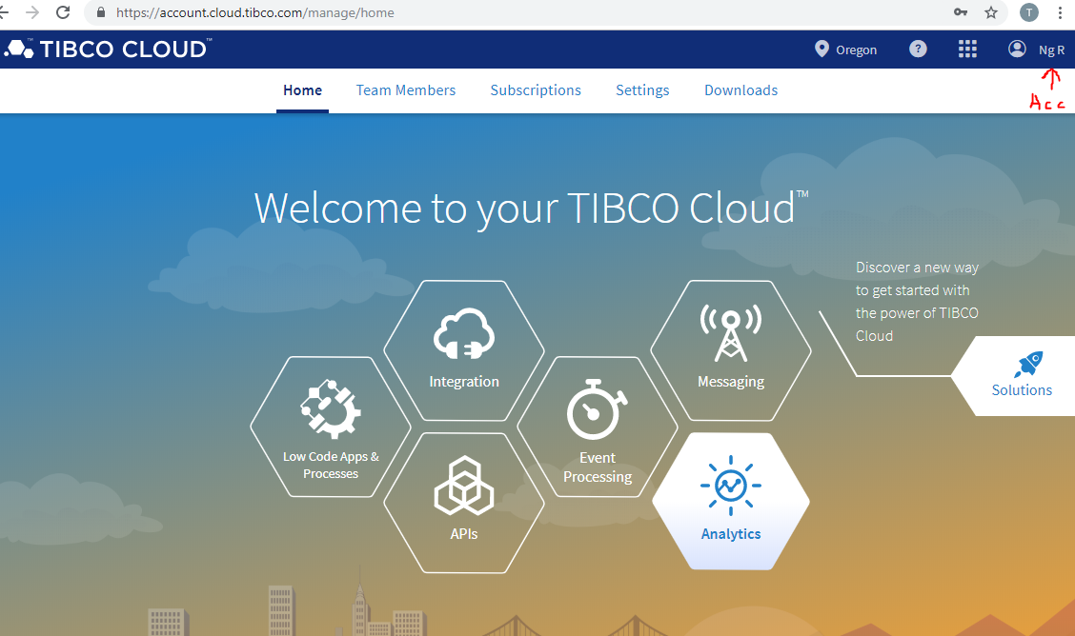

**Alternatively**, you can access Spotfire by clicking on the **“Subscriptions” tab then select “Spotfire”**, and launch the application. The website will then redirect you to the exclusive webpages for TIBCO Spotfire.

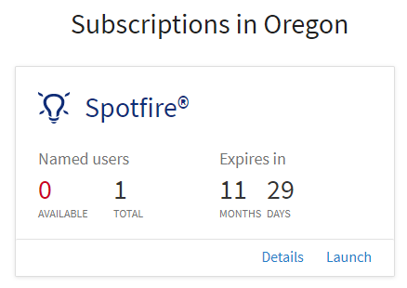

**3.2 TIBCO Spotfire Web Client**

An official documentation guide to using TIBCO Spotfire can be found [here](http://docs.spotfire.cloud.tibco.com/spotfire/index.html). I will be explaining my own version of my guide below.

To start off with TIBCO Spotfire Web Client, you will be greeted with the following screen once entered.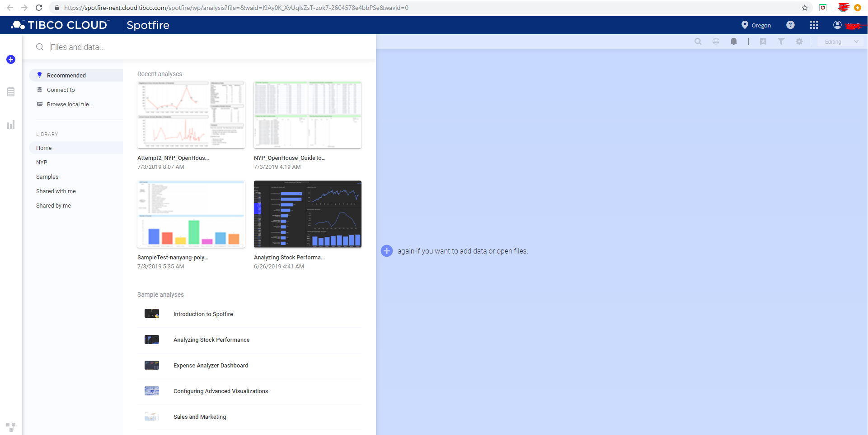

**4 How To Use**

**4.1 Loading Data**

Greeted with an empty web page prompting to add/open a data source. **To add/open a data source, click on the + icon that indicates “Files and data”**.

This page will require you to connect to a data source. The data source can be either connected online, or by browsing local files. **Upon a successful data source connection, an analysis will be created**. With the Web Client, your options for online connections are very limited to only Google Analytics and Salesforce.

As of writing this documentation, the **accepted file formats** for data sources are as follows: Microsoft Excel Workbooks (**.xlsx, .xls**), Microsoft Excel Binary Workbooks (**.xlsb**), Microsoft Excel Macro-Enabled Workbooks (**.xlsm**), comma separated values files (**.csv**), text files (**.txt**), logfiles (**.log**), TIBCO Spotfire Text Data Format files (**.stdf**), and TIBCO Spotfire Binary Data Format files (**.sbdf**). You can also open locally saved TIBCO Spotfire analysis files (**.dxp**), but you will not create a new analysis; instead an existing analysis will be opened.

**Note:** If you do not have a sample data-source for testing, please refer to “**2. Prerequisites”**, where I explain where you can get a large collection of free data-sources.

**4.2 Creating Visuals**

After providing a data-source, you are all set to create visuals with Spotfire. The Web Client does not have certain visualisation, this includes unique properties of each visual.

To create your first visual, select either “Data in analysis” or “Visualization types”.

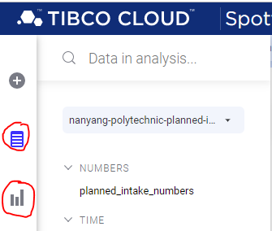

With Spotfire, you are able to connect multiple data-sources into the same project. Once you have provided a connection, the data will be saved onto the TIBCO Cloud servers. This will enable the ability to modify the table data, and even create new tables with the existing tables. The application will then display all possible data from the selected data-source.

**Note:** As the application is identifying the data by itself, it is recommended to check the data-names against the actual data-source to ensure they are the same.

**4.3 Visualisation Options**

Below will be a list of visualisations available to use for the Web Client. Each visualization will be unique and are used with different purposes. Here is a list of current available visual options:

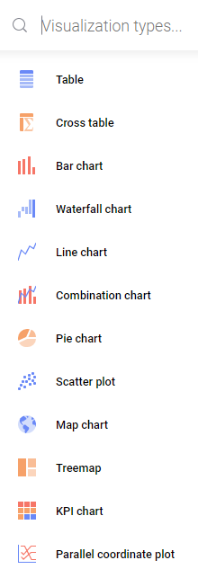

From here, it is best to explore each visualization on your own time as it requires practice to understand how to use them. To modify a visualisation, hover your cursor over a visual and right click to select the properties option. When in doubt, do refer to the official documentation guide [here](http://docs.spotfire.cloud.tibco.com/spotfire/index.html).

**Note:** Remember to save your work at “File > Save”. Do not Ctrl+S. Similar with “Undo/ Forward”. Reopening a project requires you to change from “Viewing” to “Editing”.

For a more in-depth research on the capabilities, you may refer to my “TIBCO Spotfire Desktop Application Documentation”. Although most content will only be available in the Desktop App, the concepts are fairly similar to the Web Client version.